Title: | Door Control Module  SW Component CANDriver

History
Issue status  (Index) | Maturity/Date  (draft/invalid/valid)  (dd-mmm-yyyy) | Author  Department | Check/Release  Department | Description
1.0 | Draft  31-Jan-21 | Rubén Cocoletzi | Marco Antonio Romo | Initial versión

Table of Contents
1 Purpose 3
2 Definitions and abbreviations 3
3 Realization constraints and targets 3
4 SW Conceptual design 4
5 SW Component internal breakdown 5
5.1 Functional Decomposition 5
5.2 Function void FrameTransmition (struct CANServiceFrame) 6
5.3 Function void CANDriver_ReceivedMessage (struct CANFrame) 6

Purpose
This document shows the corresponding interfaces of the CANDriver software component. This component will handle the transmission message and reception messages.

Definitions and abbreviations
Definitions
NA

Abbreviations

CAN | Controller Area Network
DCU | Door Control Module
References
N° | Document name | Reference
1 | SW Architecture | Commit: ddc45822a03f9f1781eaa4fc5b6d5874311f8e1b [ddc4582]

Realization constraints and targets

This document shows the internal behavior of CANDriver component. It lists the functionalities to communicate with other components as well as the principal tasks that are implemented to transmit and receive messages.

SW Conceptual design
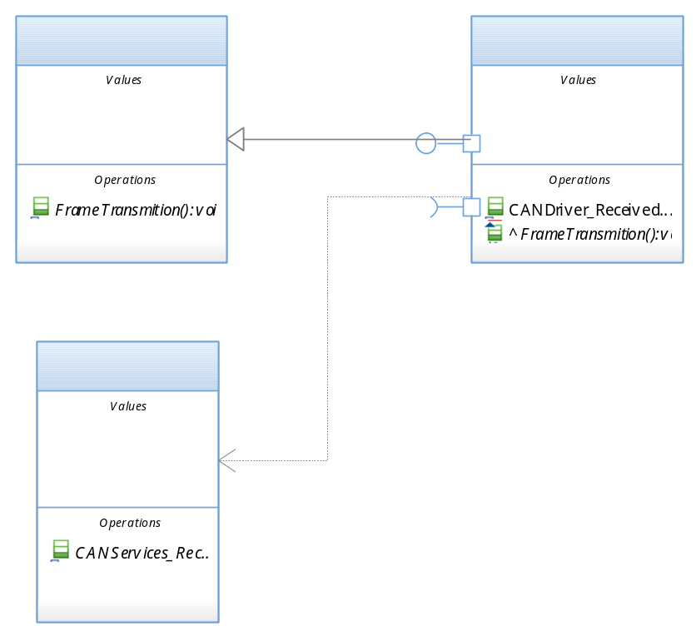

SW Component internal breakdown

Functional Decomposition
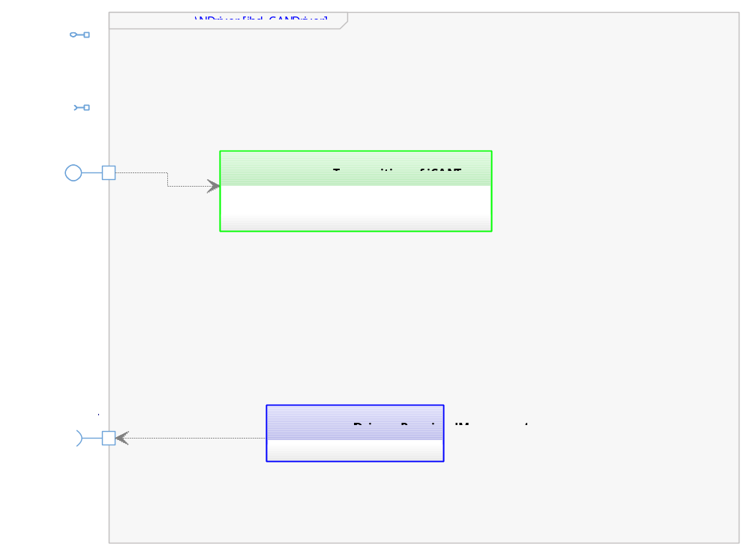

Function void FrameTransmition (struct CANServiceFrame)

Description | This function is called by CANServices to pass the corresponding structure of engineering values that DCU shall transmit. .
Parameter 1  <input| output| inout> | Struct CANServiceFrame <input>
Parameter 2..n | NA – Only use one parameter
Return Value | NA – Does not return a value.
Precondition | CAN microcontroller’s layer shall have the correct configuration.
Post condition | A CAN message shall be transmitted in the CAN Bus
Error Conditions | NA – Any error condition identified yet.
Requirements | NA – Review traceability matrix

Function void CANDriver_ReceivedMessage (struct CANFrame)
Description | This function is call by microcontroller’s lower layer to pass the received message in CAN BUS
Parameter 1  <input| output| inout> | Struct CANFrame <input>
Parameter 2..n | NA – Does not use parameters.
Return Value | NA – Does not return a value.
Precondition | CAN microcontroller’s layer shall have the correct configuration.
Post condition | CAN Services will receive a new CAN Frame.
Error Conditions | NA – Any error condition identified yet.
Requirements | NA – Review traceability matrix

